

Placement Empowerment Program

Cloud Computing and DevOps Centre

**Set Up a Private Network in the Cloud**

Create a Virtual Private Cloud (VPC) with subnets for your instances. Configure routing for internal communication between subnets.

Name:Manashaa U Department: CSE

Introduction:

In this Proof of Concept (POC), I have set up virtual network.

The virtual network data gateway lets you connect your Azure and other data services to Microsoft Fabric and the Power Platform to securely communicate with the data source, execute queries, and transmit results back to the service

Step-by-Step Overview Step

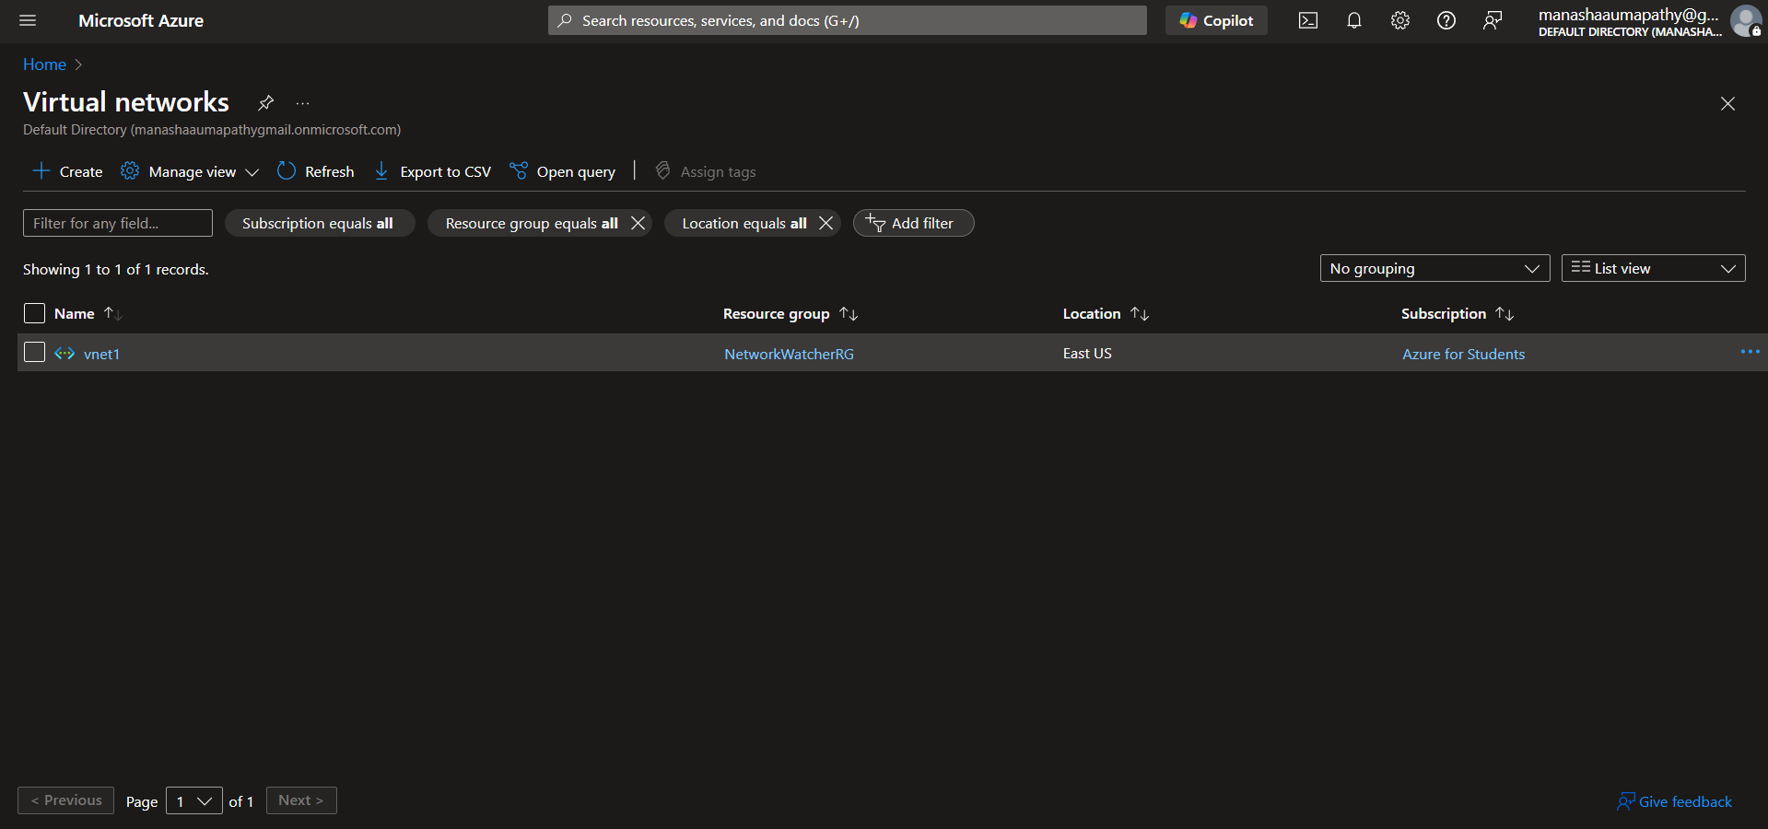

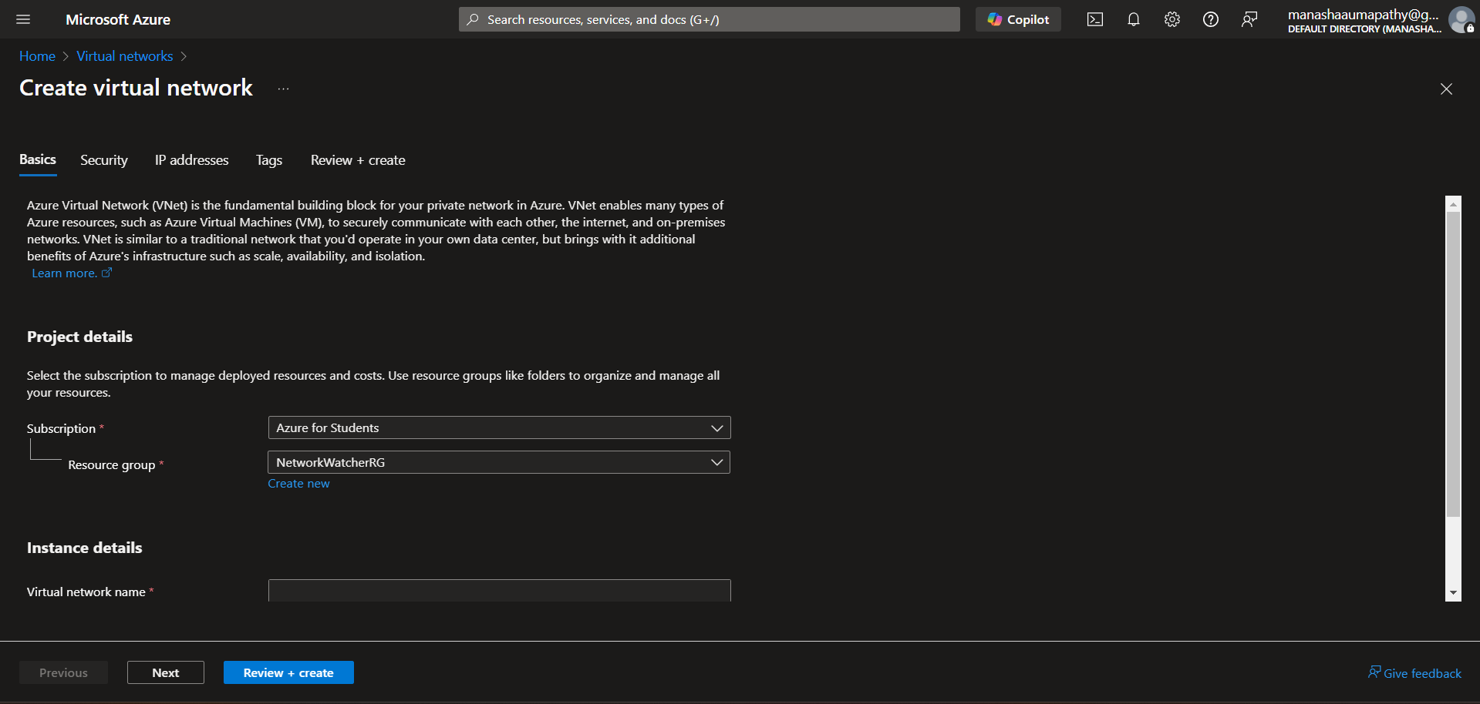

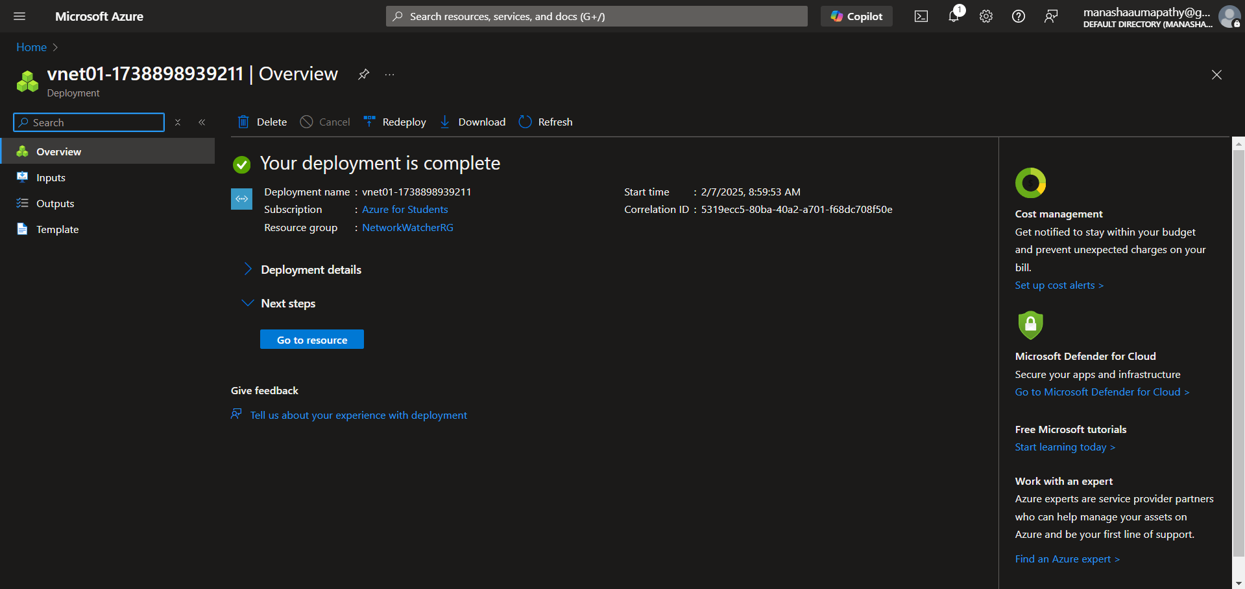

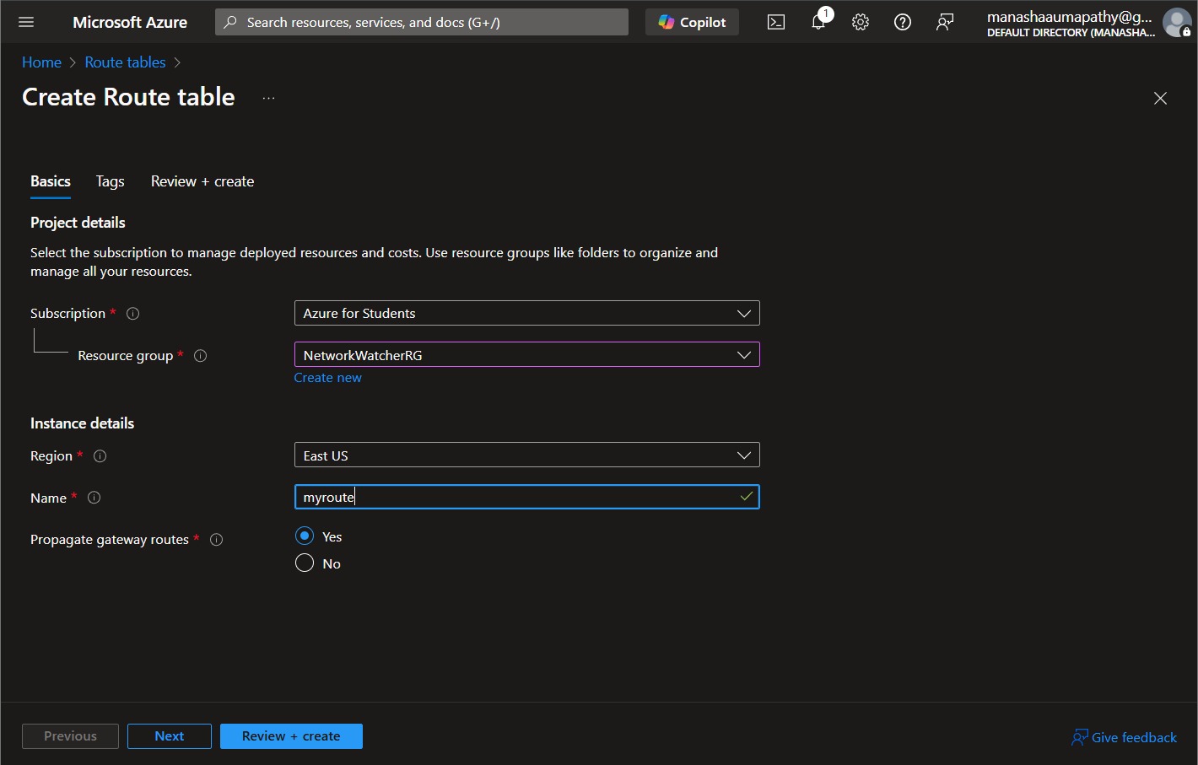

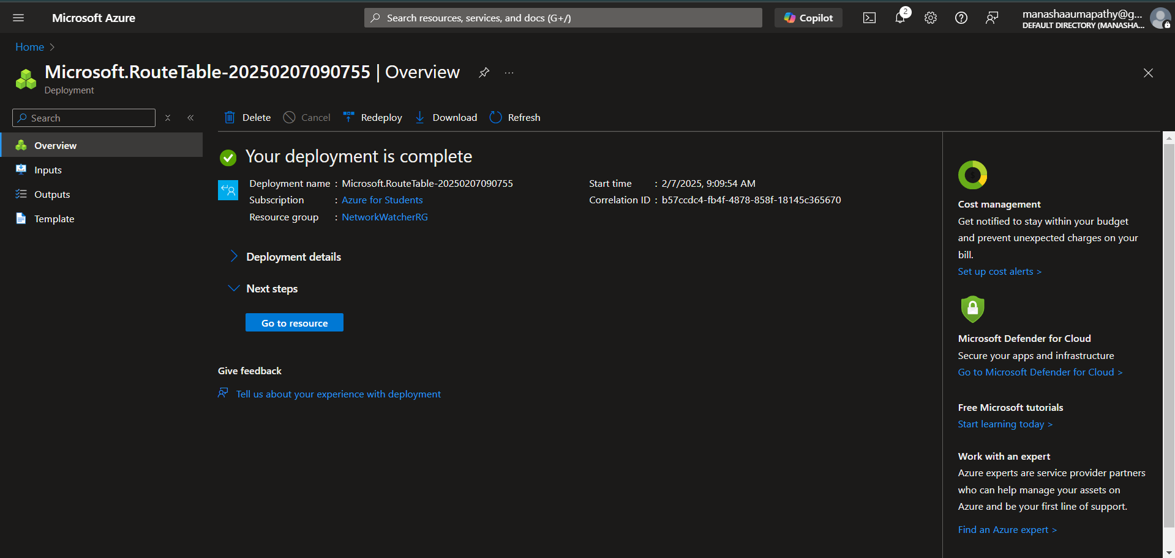

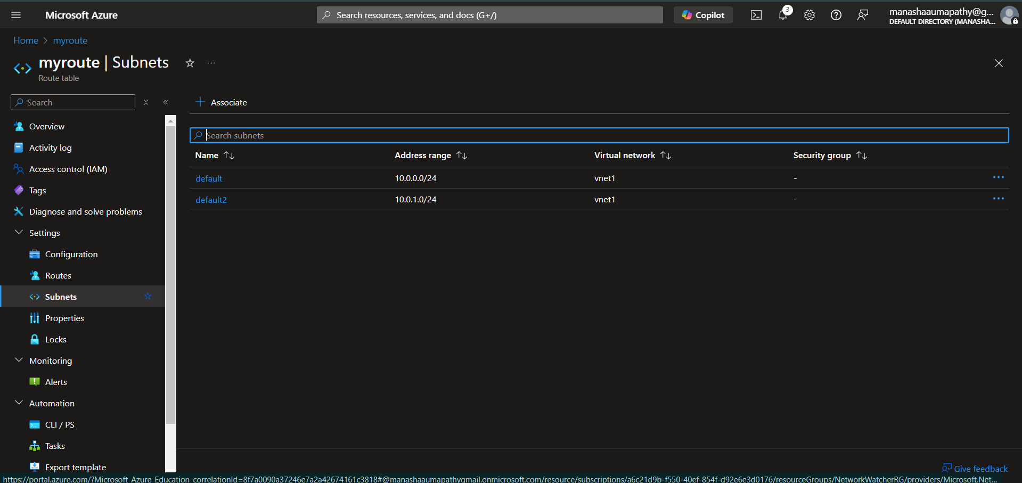

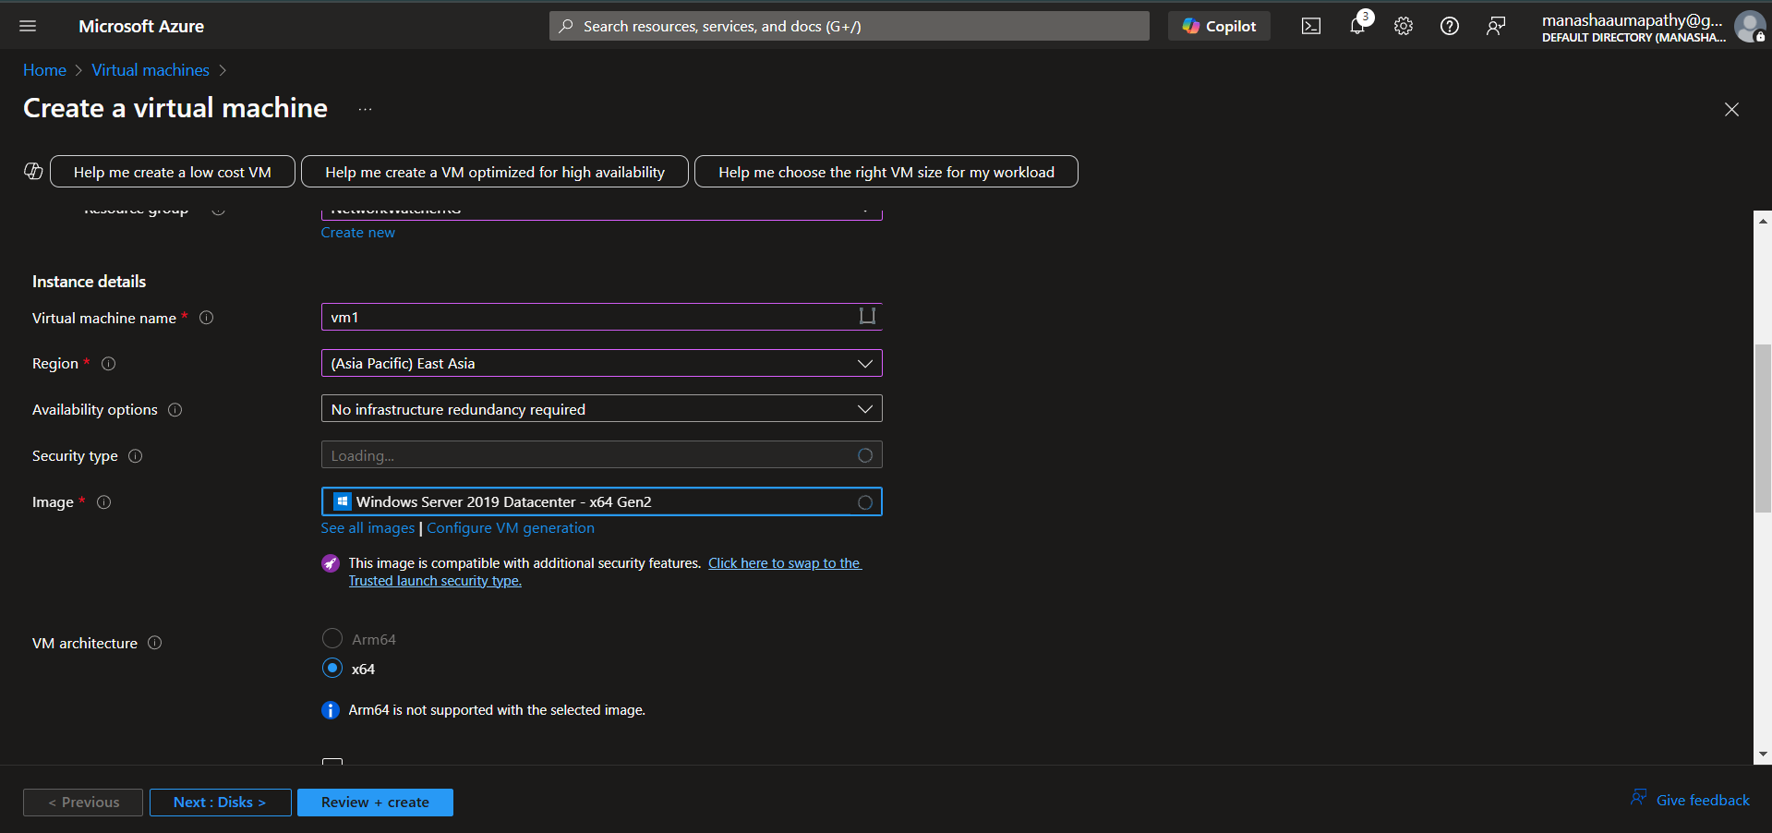

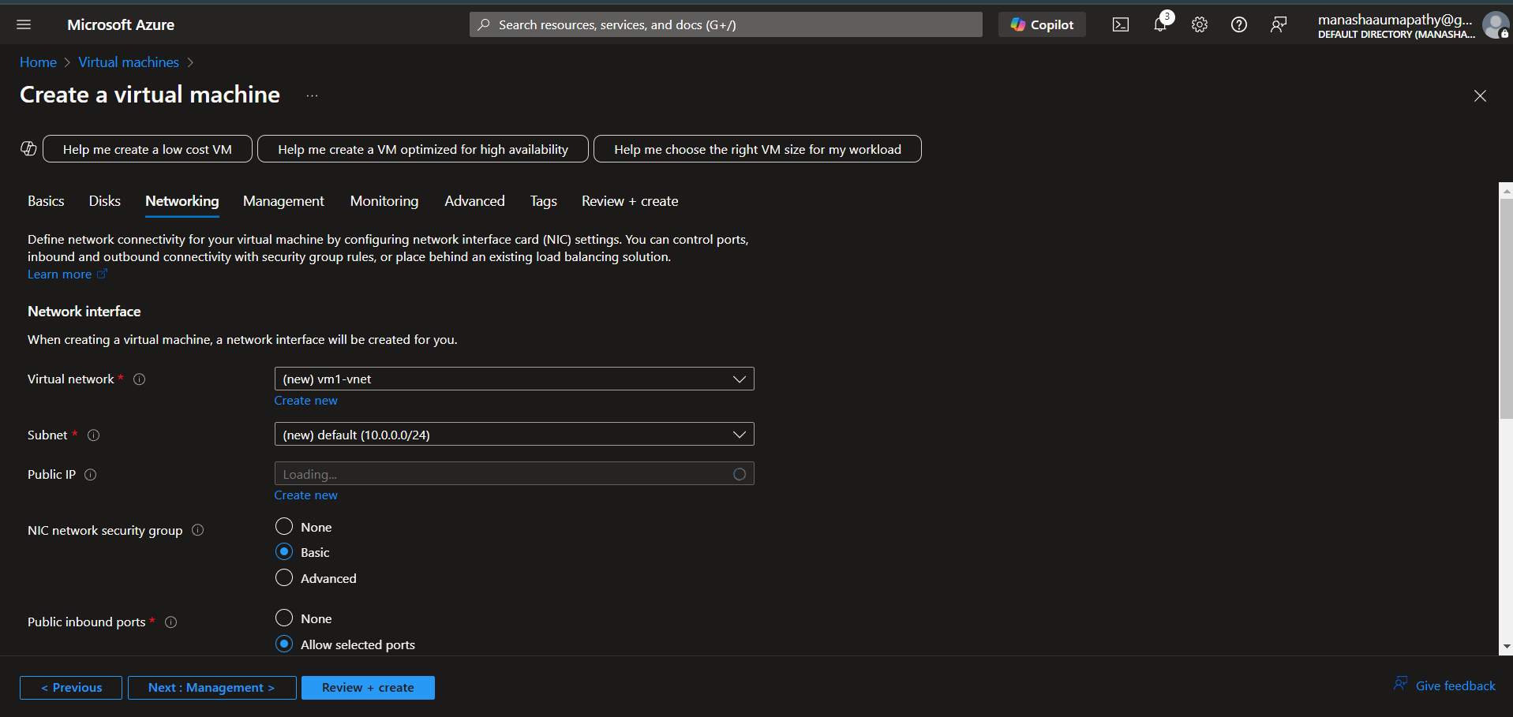

Outcome:

1)By shifting many functions to software.

2)Reduces the cost and complexity of managing network hardware and software through centralized control.